Final Project Design Phase
Computer Science - Week 11
Oct 3, 2026 - Version 0.0.4

For complete instructions and project ideas, refer to the assignment in Canvas. Specifically, review the final project requirements before you continue below. If you have not reviewed the project requirements in Canvas (you might have to go to the modules view and check the current or past week's content), you will not be able to properly complete the parts below. In addition, it may be helpful to review the information on this Drafter documentation page.

0) Project Planning and Preparation
Successful programmers spend time planning before they begin coding. After reviewing the project requirements, answer the following questions to help guide your design and development process.
- What concepts from class or previous assignments might help you complete this project? Which programming concepts (loops, conditionals, lists, classes, etc.) do you expect to use? What programming skills do you want to improve while completing this project?
Using if statements will help break down the data into separate divisions, and nested data will also be important since it can group the data efficiently. I mostly want to improve my drafter skills.

- Which parts of the project do you expect to be the easiest for you? The hardest? Why?
The easiest will probably be writing the simple helper functions that process the ballot scores. The hardest will probably be documenting all the scores by division and category, so working with heavily nested data.

- Even though you have not yet designed the final project, estimate which tasks will likely require the most time and effort? Which features or components should be implemented first?
The most important is the data collection system which will require many routes.

- What distractions might interfere with your work and how will you minimize them? What resources will you need available while working? What questions, if any, do you still have about the assignment requirements?
Just normal life I suppose, no questions.

1) Site Diagram
Create a mock-up of your planned website. We suggest you make the mockup on paper, although you can also use software like PowerPoint or Slides to make a mockup. There is other design software that could also be used, but we strongly encourage you to keep it simple. Do not spend more than 15-30 minutes detailing the mock-up. Your goal should be to make a very quick and dirty diagram, to show that you have some kind of idea.

We recommend drawing each page as a rectangle, and laying out the text, buttons, and other components inside. Then, use arrows to indicate links between pages. Label each page the way you will name each function, and then put labels on the arrows to indicate what the button links. Also write down any parameters that should come into the pages.

In addition to the pages and routes, write down what fields your `State` will have, both their names and types. Think clearly about what data will need to be persistent across the entire website.

Add photo(s) or screenshot(s) of your website mock-up and labeled diagram on the next page.

@dataclass
class State:
ranking: list[str]
ballots: list[Ballot]

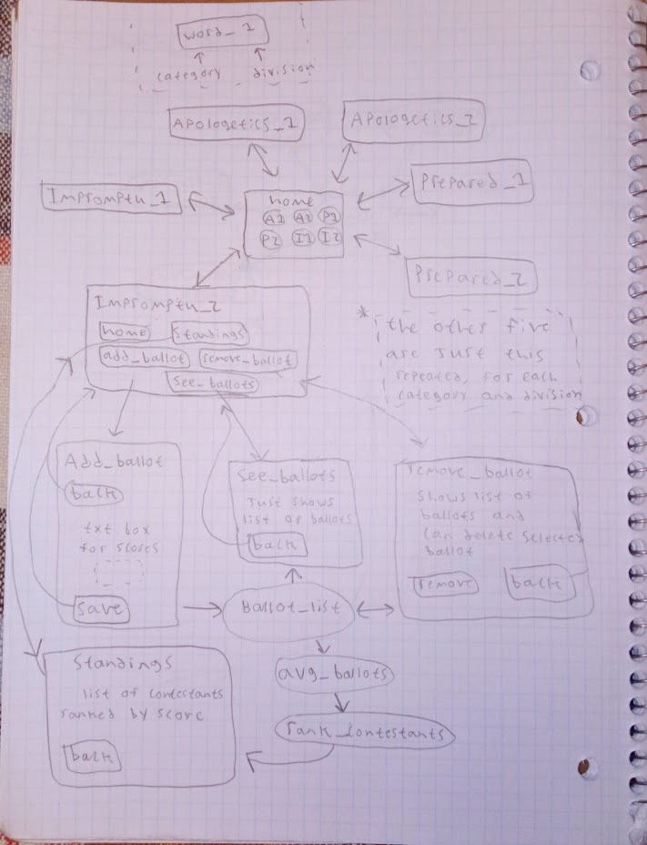
2) Implementing Requirements
This table should serve as a draft for how you will implement the requirements into your final project. You may change your ideas later on, but your final site must fulfill all the requirements.

Requirement | Implementation
Purpose/Functionality  A 1-2 sentence description of the purpose or functionality of your site | The web application takes ballot data and returns contestant standings depending on category and division.
State Dataclass Attributes  Minimum of 4 attributes, one of which must be a list/dict of instances of your second dataclass.  Briefly describe each attribute, its type, and how it will be meaningfully modified throughout the site. | Standings:  Ranking: a list of contestant names sorted by avg. score  Category: what category the standing is in  Division: what division the standing is in  Ballots: a list of ballot used to determine ranking
Second Dataclass  Your second dataclass, including its attributes, their types, and how they will be meaningfully modified (if they are modified) | Ballot:  Judge: the judges name, used to verify whose ballot is being counted  Category: determines what category the ballot is judging  Division: determines what division the ballot is judging  Score: the scoring data from the round
Routes (minimum 7)  The names of your route functions | Ballot_list_a1, ballot_list_a2,ballot_list_p1, ballot_list_p2,ballot_list_i1, ballot_list_i2, avg_ballot, rank_contestants
Pages (minimum 5)  A brief description of the pages in your site | apologetics_1, apologetics_2, prepared_1, prepared_2, impromptu_1, impromptu_2, add_ballot, see_ballot, remove_ballot, standings, home
User Input (minimum 3)  Description of user input components (TextBox, TextArea, CheckBox, or SelectBox) and their purposes  For more information on these input types, see Drafter Documentation. | Multiple text boxes to communicate score, text box for judge name, check boxes assigned to ballots for removal.
If Statements (minimum 3)  Brief description of what will be evaluated in your if statements and how they will meaningfully change the logic of the site | A protective guard in avg_ballots, a tiebreaker in rank contestants, a protective guard in the add ballot txt. box to ensure only ints are imputed.  Most of the logic will be driven by pages connecting each other and the if statements will ensure they all work properly.
Loop (minimum 1)  This loop must iterate over the list/dict of dataclass instances in your State attribute.  Description of this loop and why it is meaningful to the site | A loop in avg_ballots to iterate over the list of scores in a ballot. It will do the actual computation in the web app.

LLM Conversation
If you used an LLM in any part of this work, copy and paste every part of that conversation below. Otherwise, you may be given a zero for the assignment. Obviously, these words will not all be yours, and this is the exception to the requirement at the top of this assignment that all responses be in your own words. If you did not use an LLM to assist you in this assignment, simply say so below.
No LLM today!

Final Submission
When you are finished, download this file as a Word Document (docx) and upload the file to the appropriate assignment on Canvas.

